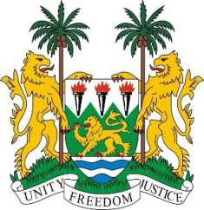
SIERRA LEONE
23rd Session of the UPR

NEPAL

4 November 2015

Mr President,

Sierra Leone welcomes the delegation of Nepal and thanks them for their second cycle national report.

Sierra Leone was deeply saddened by the loss of life and displacement of hundreds of thousands of people earlier this year following a series of destructive earthquakes in Nepal. We applaud the government on their handling of this catastrophe as well as for their willingness to collaborate effectively with the international community.

My delegation notes with interest Nepal’s National Human Rights Commission enjoys an “A” status. We also commend the government on establishing transitional justice mechanisms to address past human rights violations. Concurrently, the plans to implement free and compulsory primary education through the School Sector Reform Plan and the National Action Plan on Education for All are noteworthy.

However, trafficking in children and their sexual exploitation remain issues of concern and Sierra Leone would therefore urge Nepal to fully implement strategies to eliminate such practices and promote the social reintegration of victims back into their local communities.

Recommendations:

- Ratify the ICPPED and ICRMW.
- Ensure that provisions in the revised constitution guarantees the equal rights of women as well as their right to acquire, retain and transfer citizenship.
- Adopt a bill criminalizing harmful cultural practices, and abolish child, early and forced marriage.

- Investigate allegations of extrajudicial killings and deaths in custody as well as of trafficking in human organs.

Sierra Leone wishes Nepal every success.

Thank you, Mr President.

